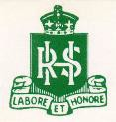

# RANDWICK BOYS’ HIGH SCHOOL

**2024 Year 7 High Potential & Gifted Education Program**

Randwick Boys’ High is pleased to advise that applications for the 2024 High Potential and Gifted Education Program for Year 7 students will be available from **Tuesday, 2nd May 2023**.

This is an exciting opportunity for academically gifted students to be part of a specialised learning program. The program offers a stimulating educational experience designed to extend students’ skills and talents across all curriculum areas.

**An information session will be held in the school library on**

***Tuesday 2nd May 2023, at 5:00pm.***

**Please register your interest with the Front Office.**

**Tel: (02) 9399 3122 Email:** [**randwickb-h.school@det.nsw.edu.au**](mailto:randwickb-h.school@det.nsw.edu.au)

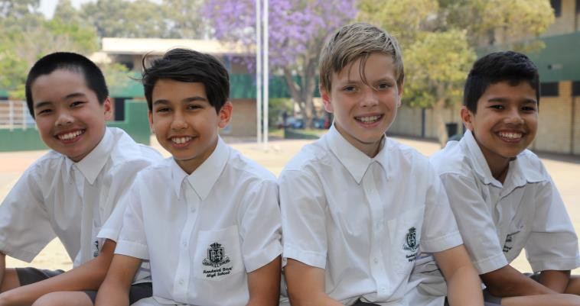

**Applications will open 2nd May, 2023**

**and close on 26th May, 2023.**

**Testing date is Saturday 13th June 2020*.***

Students who wish to gain a position in this exclusive class are required to sit an academic placement test, attend an interview and present a portfolio.

For further information, please contact Ms Emma Payne, Deputy Principal, or download the information package from our website.

[***https://randwickb-h.schools.nsw.gov.au/learning-at-our-school/gifted-and-talented-program.html***](https://randwickb-h.schools.nsw.gov.au/learning-at-our-school/gifted-and-talented-program.html)

**Randwick Boys’ High School is a co-operative, caring school with a tradition of academic, sporting and creative achievement.**

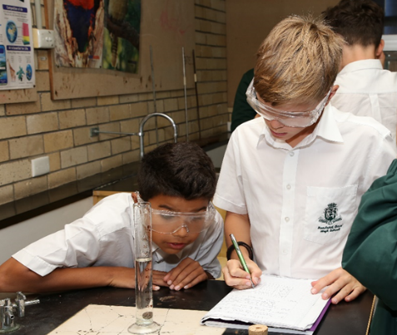

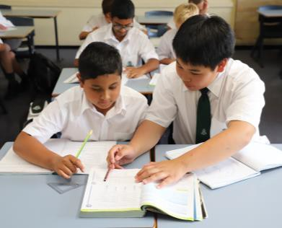

**2021/2022 Highest ATARs**

**1. 98.1**

**2. 97.95**

**3. 96.75**

**2021 Third in the State HSC Standard English**

**HSC School Ranking**

**climbed 161 places in 2019 and has been consistently maintained.**

Tel: (02) 9399 3122 Fax: (02) 9399 9546

Cnr Avoca and Rainbow Streets, Randwick <https://randwickb-h.schools.nsw.gov.au/>

Email: [randwickb-h.school@det.nsw.edu.au](mailto:randwickb-h.school@det.nsw.edu.au)

***An Exclusive Education in an Inclusive Environment***