1



***E:***

**Randwick Boys’ High School**

Guiding Young Men to Success

[www.randwickb-h.schools.nsw.edu.au](http://www.randwickb-h.schools.nsw.edu.au/)

Application Package for

2024 High Potential & Gifted Education Program

(Year 7, 8, 9* & 10)

Applications Open: 2 May, 2023

Applications Close: 26 May, 2023

*Year 9 cohort is currently full. Applications for the waiting list will still be considered.

## A link to register for the test will be available on the school’s website, from the date shown above.

*PLEASE NOTE: Late applications will NOT be accepted.*

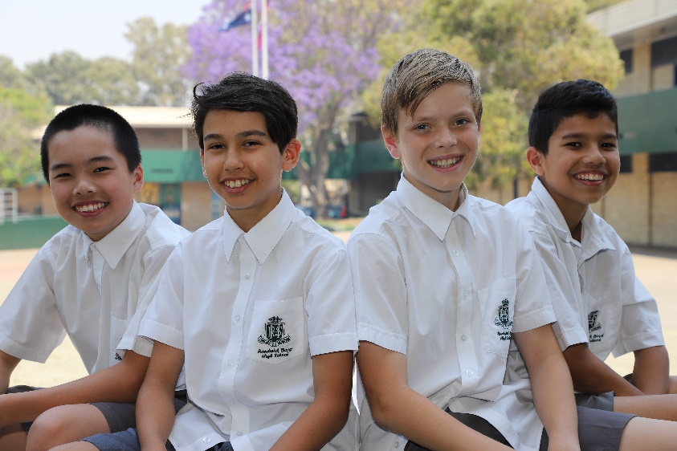

**Information Evening**…...Tuesday, 2 May, 2023 (5-6.30pm) – School Library

**Testing Date**……………..Saturday, 3 June, 2023- School Hall

**Testing Time**…………..…8:45am – 12.30pm

**Interviews**…………………Monday, 31 July – Friday, 1 September, 2023

**Notification to Students and Parents**….Week commencing Monday, 9 October, 2023

*Randwick Boys’ High School*

*Cnr Rainbow & Avoca Streets, Randwick NSW 2031*

***P:*** *02 9399 3122* ***F:*** *02 9399 9546*

***E:*** [*randwickb-h.school@det.nsw.edu.au*](mailto:randwickb-h.school@det.nsw.edu.au)

2

*this package.*

***E:***



# SCHOOL PROFILE

Randwick Boys' High School provides a safe and caring environment for your son to learn and grow, a place where he can develop his academic, sporting, social and cultural potential. By offering a diverse, challenging curriculum, well supported by a dedicated, professional staff, our students learn in a dynamic environment and become successful, lifelong learners.

Randwick Boys High School

High potential and gifted students are enriched by a variety of experiences in academic activities, sport, the arts and leadership. Participation in university challenges, STEM enrichment days, project-based learning tasks, a Sydney wide competitive boys' school sporting zone and our annual school production with Randwick Girls' High School, provide some of those experiences.

Interstate excursions provide added richness to students learning experiences. Our location enables us to maximise opportunities for students to visit places relevant to their learning, including the University of New South Wales.

Students are encouraged to explore their creative talents through innovative programs in dance, voice, drama, music and the visual arts. The creative talents of all student are nurtured and developed.

An active leadership program has been developed with the Students' Representative Council and the Student Leadership Team, comprising the school Captains, Prefects and SRC.

The school has a focus on positive behaviour for learning and in developing, in each student, the potential to achieve his best. Our students join us as boys, but they leave us as men.

# CRITERIA FOR PLACEMENT OF STUDENTS

Applicants must satisfy the following criteria:

1. **ACADEMIC MERIT**

Students must compete academically with other candidates for entry into the High Potential & Gifted Education Program. Academic merit is determined by:

* + Academic placement tested conducted by Academic Assessment Services,
  + Student School Report and NAPLAN results,
  + The provision of a portfolio of student work samples.

Details of each are set out on the following pages.

*Randwick Boys’ High School*

*Cnr Rainbow & Avoca Streets, Randwick NSW 2031*

***P:*** *02 9399 3122* ***F:*** *02 9399 9546*

***E:*** [*randwickb-h.school@det.nsw.edu.au*](mailto:randwickb-h.school@det.nsw.edu.au)

3



# Academic Placement Test

Academic Assessment Services conducts this independent and secure test in English, Mathematics and General Ability. It is set at an advanced level of difficulty. Register for the test via the School’s High Potential & Gifted Education Program Page.

Randwick Boys High School

# School Progress Report and NAPLAN results

For the Year 7, 2024 intake, and the Year 8, 9 & 10 2024 intake (limited places): The most recent Student School Report and:

Year 7, 2024

* + - Year 5, 2022 NAPLAN Results

Year 8, 9 & 10, 2024:

* + - Most recent NAPLAN Results

Both documents provide further evidence that establishes both student performance and application to learning.

# Student Portfolio and Current Photograph

In addition to the above, the Student Learning Portfolio will present samples of work, including:

* + - * A piece of creative writing.
      * Documentation showing special talents, for example, artistic, technological, historical, musical, sporting, etc.
      * Special awards that detail specific interest or abilities. E.g. academic competitions, cultural achievements and leadership acknowledgement. Portfolios will be kept by the school for some time so PLEASE DO NOT INCLUDE ORIGINALS. Following placement offers, portfolios will be available for collection.

***NOTE:***

*Following the Academic Placement Test, successful candidates will be called to interview, where they present their School Reports and Portfolio. Neither of these items will be required at the time of the Academic Placement Test.*

1. **RESIDENCE**
   * Students must be Australian citizens or entitled to study in Australia.
   * Students from non-government primary schools may also apply.

*Randwick Boys’ High School*

*Cnr Rainbow & Avoca Streets, Randwick NSW 2031*

***P:*** *02 9399 3122* ***F:*** *02 9399 9546*

***E:*** [*randwickb-h.school@det.nsw.edu.au*](mailto:randwickb-h.school@det.nsw.edu.au)

***E:***

4



# Family placement claim

Randwick Boys High School

Where students have equal results, the student with a family placement claim will be given priority. For most students, this will have little effect on the outcome. Parents may make a family placement claim if a brother currently attends the school.

**```````**

***E:***

# TEST INFORMATION

The Randwick Boys’ High School High Potential & Gifted Education Program Placement Test will be conducted at the school on Saturday, 3June 2023.

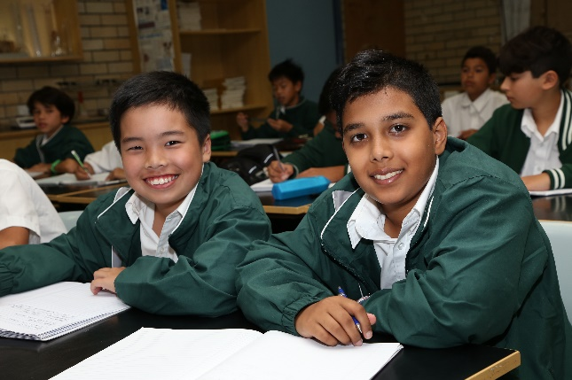

The testing timetable is as follows:

* + Start: 8:45am
  + Recess: 10:30am
  + Second session: 11:00am
  + Finish: 12:30pm

The test is administered by an independent assessor to provide a secure test that will be unavailable for scrutiny before or after the test session.

In general, academic research does not indicate that coaching or practice will significantly improve the results of students on ability tests.

Students are assessed in:

* + Reasoning and problem solving,
  + Mathematical achievement and reasoning,
  + Reading comprehension,
  + Written expression.

Each test is approximately 40 minutes in duration. Applicants should not expect to answer every question.

# COST FOR APPLICANTS IS $70

This cost is incurred by the school hiring an independent assessor who provides a written report on each student’s results. A personalised student report will be delivered to parents, either during the interview process, or by mail, after the selection process is completed.

# THE FEE IS NON-REFUNDABLE AND MUST BE PAID UPON

**APPLICATION. (Register via the school’s website from 2 May, 2023).**

*Randwick Boys’ High School*

*Cnr Rainbow & Avoca Streets, Randwick NSW 2031*

***P:*** *02 9399 3122* ***F:*** *02 9399 9546*

***E:*** [*randwickb-h.school@det.nsw.edu.au*](mailto:randwickb-h.school@det.nsw.edu.au)

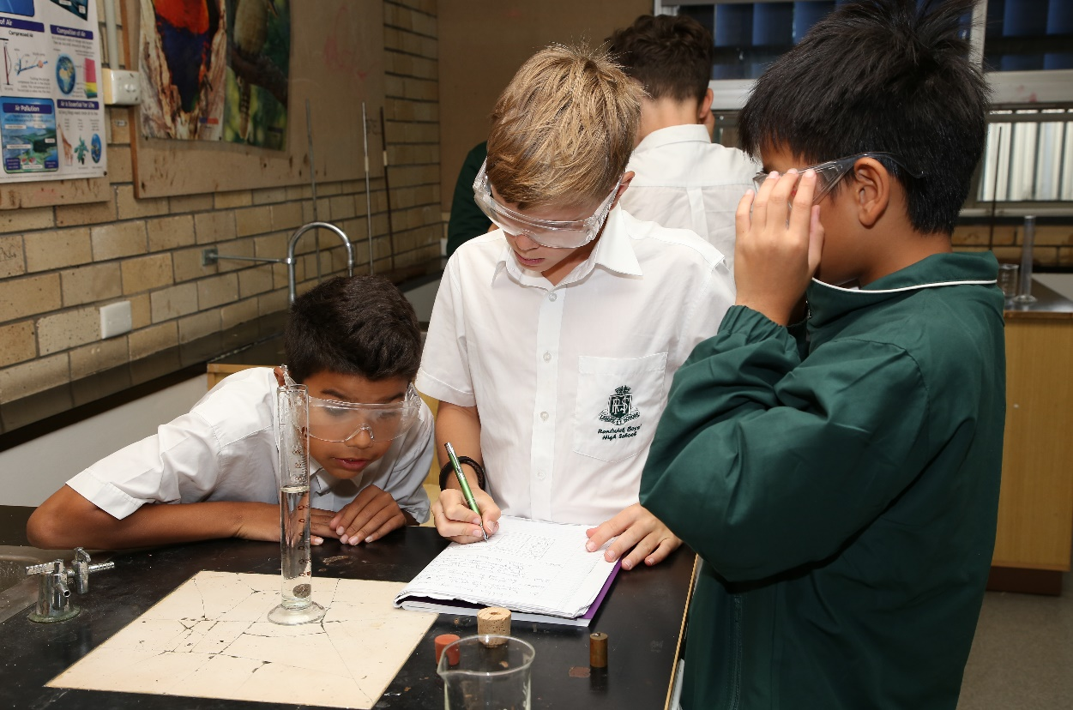5

Randwick Boys High School



# NO CONFIRMATION LETTER WILL BE SENT. RECEIPT OF PAYMENT CONFIRMS YOUR PLACE FOR THE TEST.

**ILLNESS AND MISADVENTURE**

All students wishing to be selected must be present on the testing day. If a student is unable to take the test on the stated day, and the reasons are validated by such evidence as a Medical Certificate, he will be invited to take the test at a later date if the documents provided with the application are sufficiently supportive of his eligibility to take a place in the class. This decision will be made by the Selection Committee.

Should circumstances, such as sickness or an accident, prevent a student from taking the test or from doing his best, you should advise the school immediately. You must include a Medical Certificate if the candidate was sick.

# SELECTION COMMITTEE

A Selection Committee for the school will meet to choose students using the “Criteria for Placement” listed on Page 3. The Selection Committee comprises three of the following: Principal, Deputy Principal, Year Advisor or a Head Teacher.

# ENQUIRIES

Enquiries about courses or programs offered can be made by visiting the website: <https://randwickb-h.schools.nsw.gov.au/learning-at-our-school/gifted-and-talented-program.html>. All other enquiries can be directed to the attention of the Deputy Principal at Randwick Boys’ High School at the address or numbers listed in the footer of this package.

*Randwick Boys’ High School*

*Cnr Rainbow & Avoca Streets, Randwick NSW 2031*

***P:*** *02 9399 3122* ***F:*** *02 9399 9546*

***E: All*** [*randwickb-h.school@det.nsw.edu.au*](mailto:randwickb-h.school@det.nsw.edu.au)

***E:***