Return to school in 2020

Wednesday 29 January – Year 7, 11 and 12
new enrolments

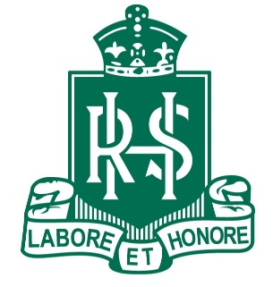
Thursday 30 January – Year 8, 9 and 10

